SEASONAL EMPLOYMENT OPPORTUNITIES

Natural Resources- Botany

SUMMER 2016

WILLAMETTE NATIONAL FOREST

DETROIT RANGER DISTRICT
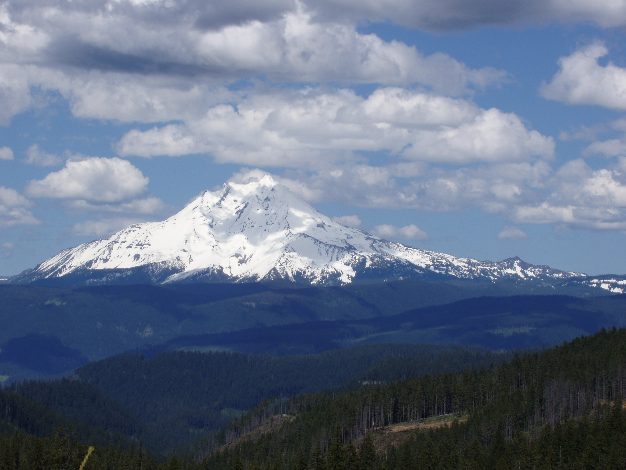

There will be several botany job opportunities on the Detroit Ranger District in Detroit, Oregon this upcoming field season.
Biological Science Technician (Botany) GS-05
Tentative Start date: April 18th to the end of September
You must apply under “Detroit”. See below on how to find announcement.

Duty Stations: Seasonals can be stationed at Detroit, Oregon.
Housing: Government provided housing may be available at Detroit. Cost is more than estimated $7.00 a day approximately $200/month.

About the Positions
The position will be involved in a variety of botany-related tasks that help support the District’s botanical and timber programs.
The botany/weed positions will include botanical surveys of rare plants, special habitats and noxious weeds. Surveys will be done using several tools such as GPS equipment, maps and field data forms to collect data. Other duties include weed control and some monitoring.

Field work is a major component of these positions. The Detroit Ranger District includes some steep terrain. Individuals working in these positions should expect to work outdoors rain or shine, in terrain that at times can be quite steep, and at tasks that may be considered strenuous.

Training will be provided and will include CPR/first aid, Defensive driving, 4x4 driving, radios, and all safety involved issues. Survey and field equipment such as GPS, navigational, maps, possibly GIS and local issues.

About the Detroit Ranger District
The Detroit Ranger District is the most northern District on the Willamette National Forest. The District encompasses about 300,000 acres, and includes outstanding features such as Mt. Jefferson Wilderness, Opal Creek Scenic Recreation Area and Wilderness, the North Cascades National Scenic Byway and the Detroit Lake Reservoir. The District has a large workload and keeps its 40+ permanent employees and approximately 50+ temporary employees very busy.
The elevation range for the District is between 1500 feet and 10,000 feet (Mt. Jefferson). The average temperatures range from 37° low to 49° high in December and 51° low to 82° high in August. Average yearly precipitation is around 80 inches, which occurs primarily from October to April. Snowfall occurs in December through February. The heavy recreation season occurs between Memorial Day and Labor Day when Detroit Lake is at full pool.

Housing is available. Housing for resource staff is 2 bedroom duplexes with 2 beds in each room. You may or may not share with another seasonal. Each unit has 2 bathrooms, kitchen and living room. Given the remote nature of the duty station, a personal vehicle is helpful for grocery and entertainment-related trips.

About the Detroit Community
The community of Detroit is situated in the heart of the Cascades—about 50 miles east of Salem, Oregon on Highway 22, and 80 miles west of Bend, Oregon. The District office is one mile west of the City of Detroit and is located in the Santiam River Canyon
At one time, Detroit was a logging community, but is now mostly a recreation oriented community. Detroit has about 300 permanent residents, but increases during the summer to about 500 residents. Summer activities include hiking, backpacking, river rafting & kayaking, hunting, fishing, and mountain biking, but a main summer attraction that draws thousands of recreationists each year is the Detroit Lake Reservoir. Detroit Lake is the most popular lake in Oregon and is known for its excellent water skiing, boating, fishing and camping. Winter activities include backcountry skiing, snowshoeing, snowmobiling, and snowboarding/downhill skiing at nearby Hoodoo Ski area and Mt. Bachelor.
Invasive Plant work: Duties include; identifying invasive non-native plants using various field guides, surveying for target plants, collecting data on infestation location and status, and treating invasive plant infestations. Accurately and legibly records data related to invasive non-native plant treatments according to specific protocols.
Timber sale surveys.. Duties include; the skills and ability to identify common, rare plants and common invasive plants of the western cascades, surveying for target plants, collecting data on population location and status, and accurately and legibly record data related to invasive non-native plant treatments according to specific protocols.
Other work. there are other smaller jobs that all botanists will do including survey and hand pulling of weeds from previous timber sales, rare plant and weed monitoring throughout the district including the wilderness, possibly working with other crews including highschool crews, seed collection and many other opportunities as they arise.
May perform highly physical labor and daily hiking often to remote locations in rugged terrain under possible adverse weather conditions. Use global positioning systems, aerial photographs, topographic maps, and/or compass in navigation. A portion of time may be dedicated to data entry and other duties in a laboratory/office setting. Field work is a major component for all of these positions. Individuals working in these positions should expect to work outdoors rain or shine, in terrain that at times can be quite steep, and at tasks that may be considered strenuous.
Announcement Numbers:
# 16-TEMP-R6-0404-5PLNT-DTfor the GS-0404-05, Biological Science Technician (Plants)

Opens 11/30/2015 Closes 12/7/2015

How to Apply
HOW TO APPLY:
Go to https://www.usajobs.gov/
Step 1 – Create a USAJOBS account at www.usajobs.gov. It is recommended that as part of your profile you set up automatic email notification to be informed when the status of your application changes.
Step 2 - Create a Resume with USAJOBS or upload a Resume into your USAJOBS account. You may want to customize your resume to ensure it documents duties and accomplishments you have gained that are directly related to this position in order to verify that qualifications are met. In addition, your resume must support your responses to the online questionnaire (you may preview the online questionnaire by clicking on the link at the end of the How You Will Be Evaluated section of the job announcement). If you are using education in lieu of or as a supplemental to experience, transcripts are required to be attached.
Step 3 - Search for the job announcement number. Please read the entire announcement and all the instructions before you begin. Click "Apply Online" and follow the prompts to complete the Occupational Questionnaire and attach any additional documents that may be required. Make sure you select a potential duty station. You can update your application or documents anytime while the announcement is open. Simply log into your USAJOBS account and click on "Application Status." Click on the position
Title and then select Update Application to continue.

Position qualifications can be found at: http://www.opm.gov/qualifications/. Announcements for these positions will be posted on the USAJOBS websites.

For more information regarding specific seasonal positions, please contact:

Botany
Chris Wagner (Botanist) 503-854-3890
clwagner@fs.fed.us

