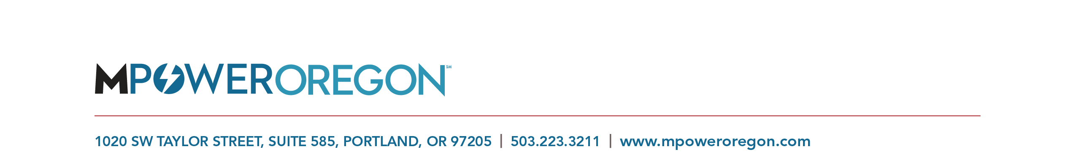

Utility Engagement Intern

Position: Intern
Where: Downtown Portland Oregon
Time: Estimated 40-60 hours prior to the end of April
Pay: $17 per hour

MPower
MPower Oregon (“MPower”) exists to address the inequitable impact of climate change on low-income communities. We do that by finding and implementing new models for bringing significant and lasting energy and water efficiency upgrades to multifamily affordable housing. MPower, a wholly owned subsidiary of the Network for Oregon Affordable Housing (NOAH), offers a simple, integrated solution for lowering operating costs and increasing the comfort and health outcomes at affordable multifamily properties. We deliver immediate savings to owners and occupants through energy and water efficiency building upgrades and on-going support services. MPower is a true triple bottom line organization committed to adding value to people, the planet and balanced profits.

Position Description
The Utility Engagement Intern (”Intern”) will report to MPower’s Managing Director and be exposed to the heart of program development and delivery. The Intern will conduct market research and assist in development of an engagement plan to increase utility incentives available to multifamily affordable properties. The Intern will have the opportunity to explore utility programs and learn about finance and conservation offerings in affordable housing. We are looking for someone with a can-do attitude and who is creative, nimble and can adapt to ever changing market indicators as we grow the MPower offering.
Responsibilities
- Research and document available utility incentives throughout Oregon
- Prepare tables, graphs, fact sheets, and written reports summarizing project results and program outcomes
- Work with MPower staff to develop a utility engagement plan in an effort to access and increase available incentives for multifamily affordable properties
Required Skills and Experience
- Strong presentation, written and interpersonal skills
- Demonstrated research skills
- Previous experience in utility contracting, affordable housing and/or building science, a plus
- High degree of flexibility in an innovative work environment
- Self-directed but must work well as part of a team
- Ability to meet deadlines and deliverables
- Sense of humor and humility a must

