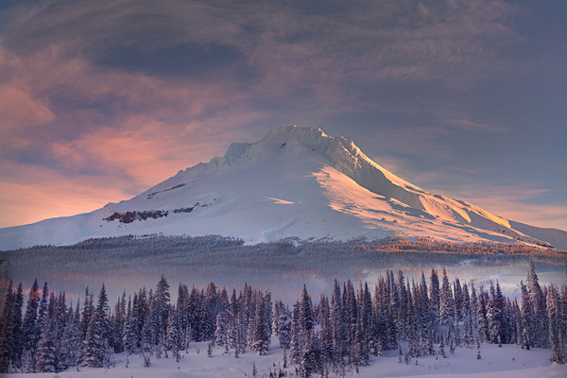
Join us for a few hours of walking in the Mt Hood woods and a discussion of the role the mountain plays in people’s lives. Some want to climb, ski, and hike while others prefer to admire the mountain from afar. Who should have access and for what purposes? How do we maintain a balance between recreation and preservation, between urban and wilderness?

Saturday Feb 4
Sign up at the College Outdoors Office

A College Outdoors Snowshoeing Trip

with Professor Anne Bentley

People and the Mountain

